**Aim: To study different types of layouts and Toast class.**

**Title: Study of different layouts and Toast class.**

* **THEORY:**
  + **Layouts:**

1. A layout defines the structure for a user interface in app, such as in an activity.
2. All elements in the layout are built using a hierarchy of View and ViewGroup objects.
3. A View usually draws something the user can see and interact with. Whereas a ViewGroup is an invisible container that defines the layout structure for View and other ViewGroup.
4. The View objects are usually called "widgets" and can be one of many subclasses, such as Button or TextView. The ViewGroup objects are usually called "layouts" can be one of many types that provide a different layout structure, such as LinearLayout or ConstraintLayout .
5. Following are different types of layouts in Android:
   1. **Linear Layout:** LinearLayout is a view group that aligns all children in a single direction, vertically or horizontally.
   2. **Relative Layout:** RelativeLayout is a view group that displays child views in relative positions.
   3. **Table Layout:** TableLayout is a view that groups views into rows and columns.
   4. **Absolute Layout:** AbsoluteLayout enables you to specify the exact location of its children.
   5. **Frame Layout:** The FrameLayout is a placeholder on screen that you can use to display a single view.
   6. **List View:** ListView is a view group that displays a list of scrollable items.
   7. **Grid View:** GridView is a ViewGroup that displays items in a two-dimensional, scrollable grid.
   * **Toast:**
6. A toast provides simple feedback about an operation in a small popup.
7. It only fills the amount of space required for the message and the current activity remains visible and interactive.
8. Toasts automatically disappear after a timeout.
9. The android.widget.Toast class is the subclass of java.lang.Object class.
10. For e.g.:

Toast.makeText(getApplicationContext(),"HelloWorld",Toast.LENGTH_SHORT).show();

**A)** **Design a Registration form to show the working of different layout:**

* **CODE:**
  + **Activity_main.xml:**

<?xml version="1.0" encoding="utf-8"?>  
<androidx.constraintlayout.widget.ConstraintLayout xmlns:android="http://schemas.android.com/apk/res/android"  
 xmlns:app="http://schemas.android.com/apk/res-auto"  
 xmlns:tools="http://schemas.android.com/tools"  
 android:layout_width="match_parent"  
 android:layout_height="match_parent"  
 tools:context=".MainActivity">  
  
 <EditText  
 android:id="@+id/divi"  
 android:layout_width="wrap_content"  
 android:layout_height="48dp"  
 android:ems="10"  
 android:inputType="textPersonName"  
 android:hint="Enter Division"  
 app:layout_constraintBottom_toBottomOf="parent"  
 app:layout_constraintEnd_toEndOf="parent"  
 app:layout_constraintHorizontal_bias="0.079"  
 app:layout_constraintStart_toStartOf="parent"  
 app:layout_constraintTop_toTopOf="parent"  
 app:layout_constraintVertical_bias="0.609" />  
  
 <EditText  
 android:id="@+id/dept"  
 android:layout_width="wrap_content"  
 android:layout_height="48dp"  
 android:ems="10"  
 android:inputType="textPersonName"  
 android:hint="Enter Department"  
 app:layout_constraintBottom_toBottomOf="parent"  
 app:layout_constraintEnd_toEndOf="parent"  
 app:layout_constraintHorizontal_bias="0.079"  
 app:layout_constraintStart_toStartOf="parent"  
 app:layout_constraintTop_toTopOf="parent"  
 app:layout_constraintVertical_bias="0.484" />  
  
 <EditText  
 android:id="@+id/roll"  
 android:layout_width="wrap_content"  
 android:layout_height="48dp"  
 android:ems="10"  
 android:inputType="textPersonName"  
 android:hint="Enter Roll_No"  
 app:layout_constraintBottom_toBottomOf="parent"  
 app:layout_constraintEnd_toEndOf="parent"  
 app:layout_constraintHorizontal_bias="0.079"  
 app:layout_constraintStart_toStartOf="parent"  
 app:layout_constraintTop_toTopOf="parent"  
 app:layout_constraintVertical_bias="0.367" />  
  
 <EditText  
 android:id="@+id/city"  
 android:layout_width="wrap_content"  
 android:layout_height="48dp"  
 android:ems="10"  
 android:inputType="textPersonName"  
 android:hint="Enter City"  
 app:layout_constraintBottom_toBottomOf="parent"  
 app:layout_constraintEnd_toEndOf="parent"  
 app:layout_constraintHorizontal_bias="0.079"  
 app:layout_constraintStart_toStartOf="parent"  
 app:layout_constraintTop_toTopOf="parent"  
 app:layout_constraintVertical_bias="0.26" />  
  
 <EditText  
 android:id="@+id/name"  
 android:layout_width="wrap_content"  
 android:layout_height="48dp"  
 android:ems="10"  
 android:inputType="textPersonName"  
 android:hint="Enter Name"  
 app:layout_constraintBottom_toBottomOf="parent"  
 app:layout_constraintEnd_toEndOf="parent"  
 app:layout_constraintHorizontal_bias="0.079"  
 app:layout_constraintStart_toStartOf="parent"  
 app:layout_constraintTop_toTopOf="parent"  
 app:layout_constraintVertical_bias="0.165" />  
  
 <TextView  
 android:id="@+id/textView2"  
 android:layout_width="335dp"  
 android:layout_height="44dp"  
 android:text="REGISTRATION FORM"  
 android:textSize="34sp"  
 app:layout_constraintBottom_toBottomOf="parent"  
 app:layout_constraintEnd_toEndOf="parent"  
 app:layout_constraintStart_toStartOf="parent"  
 app:layout_constraintTop_toTopOf="parent"  
 app:layout_constraintVertical_bias="0.023" />  
  
 <Button  
 android:id="@+id/accept"  
 android:layout_width="139dp"  
 android:layout_height="48dp"  
 android:text="Submit"  
 android:onClick="onClick"  
 app:layout_constraintBottom_toBottomOf="parent"  
 app:layout_constraintEnd_toEndOf="parent"  
 app:layout_constraintStart_toStartOf="parent"  
 app:layout_constraintTop_toTopOf="parent"  
 app:layout_constraintVertical_bias="0.771" />  
</androidx.constraintlayout.widget.ConstraintLayout>

* + **Activity_display_data.xml:**

<?xml version="1.0" encoding="utf-8"?>  
<androidx.constraintlayout.widget.ConstraintLayout xmlns:android="http://schemas.android.com/apk/res/android"  
 xmlns:app="http://schemas.android.com/apk/res-auto"  
 xmlns:tools="http://schemas.android.com/tools"  
 android:layout_width="match_parent"  
 android:layout_height="match_parent"  
 tools:context=".DisplayData">  
  
 <TextView  
 android:id="@+id/textView8"  
 android:layout_width="393dp"  
 android:layout_height="51dp"  
 android:text="REGISTRATION SUCCESS"  
 android:textSize="34sp"  
 app:layout_constraintBottom_toBottomOf="parent"  
 app:layout_constraintEnd_toEndOf="parent"  
 app:layout_constraintStart_toStartOf="parent"  
 app:layout_constraintTop_toTopOf="parent"  
 app:layout_constraintVertical_bias="0.023" />  
  
 <TextView  
 android:id="@+id/dis_name"  
 android:layout_width="400dp"  
 android:layout_height="48dp"  
 android:text="TextView"  
 android:textAlignment="center"  
 android:textSize="30sp"  
 app:layout_constraintBottom_toBottomOf="parent"  
 app:layout_constraintEnd_toEndOf="parent"  
 app:layout_constraintHorizontal_bias="0.498"  
 app:layout_constraintStart_toStartOf="parent"  
 app:layout_constraintTop_toTopOf="parent"  
 app:layout_constraintVertical_bias="0.268" />  
  
 <TextView  
 android:id="@+id/dis_dep"  
 android:layout_width="400dp"  
 android:layout_height="48dp"  
 android:text="TextView"  
 android:textAlignment="center"  
 android:textSize="30sp"  
 app:layout_constraintBottom_toBottomOf="parent"  
 app:layout_constraintEnd_toEndOf="parent"  
 app:layout_constraintHorizontal_bias="0.498"  
 app:layout_constraintStart_toStartOf="parent"  
 app:layout_constraintTop_toTopOf="parent"  
 app:layout_constraintVertical_bias="0.564" />  
  
 <TextView  
 android:id="@+id/dis_city"  
 android:layout_width="400dp"  
 android:layout_height="48dp"  
 android:text="TextView"  
 android:textAlignment="center"  
 android:textSize="30sp"  
 app:layout_constraintBottom_toBottomOf="parent"  
 app:layout_constraintEnd_toEndOf="parent"  
 app:layout_constraintHorizontal_bias="0.498"  
 app:layout_constraintStart_toStartOf="parent"  
 app:layout_constraintTop_toTopOf="parent"  
 app:layout_constraintVertical_bias="0.373" />  
  
 <TextView  
 android:id="@+id/dis_div"  
 android:layout_width="400dp"  
 android:layout_height="48dp"  
 android:text="TextView"  
 android:textAlignment="center"  
 android:textSize="30sp"  
 app:layout_constraintBottom_toBottomOf="parent"  
 app:layout_constraintEnd_toEndOf="parent"  
 app:layout_constraintHorizontal_bias="0.498"  
 app:layout_constraintStart_toStartOf="parent"  
 app:layout_constraintTop_toTopOf="parent"  
 app:layout_constraintVertical_bias="0.66" />  
  
 <TextView  
 android:id="@+id/dis_roll"  
 android:layout_width="400dp"  
 android:layout_height="48dp"  
 android:text="TextView"  
 android:textAlignment="center"  
 android:textSize="30sp"  
 app:layout_constraintBottom_toBottomOf="parent"  
 app:layout_constraintEnd_toEndOf="parent"  
 app:layout_constraintHorizontal_bias="0.498"  
 app:layout_constraintStart_toStartOf="parent"  
 app:layout_constraintTop_toTopOf="parent"  
 app:layout_constraintVertical_bias="0.476" />  
  
</androidx.constraintlayout.widget.ConstraintLayout>

* + **MainActivity.java:**

package com.example.practical_1;  
  
import androidx.appcompat.app.AppCompatActivity;  
  
import android.content.Intent;  
import android.os.Bundle;  
import android.view.View;  
import android.widget.Button;  
import android.widget.EditText;  
  
public class MainActivity extends AppCompatActivity {  
 Button send_button;  
 @Override  
 protected void onCreate(Bundle savedInstanceState) {  
 super.onCreate(savedInstanceState);  
 setContentView(R.layout.activity_main);  
 send_button = (Button) findViewById(R.id.accept);  
 EditText object1 = (EditText)findViewById(R.id.name);  
 EditText object2 = (EditText)findViewById(R.id.city);  
 EditText object3 = (EditText)findViewById(R.id.roll);  
 EditText object4 = (EditText)findViewById(R.id.dept);  
 EditText object5 = (EditText)findViewById(R.id.divi);  
  
 send_button.setOnClickListener(new View.OnClickListener() {  
  
  
 @Override  
 public void onClick(View v) {  
 String name=object1.getText().toString();  
 String city=object2.getText().toString();  
 String roll=object3.getText().toString();  
 String dept=object4.getText().toString();  
 String div=object5.getText().toString();  
 Intent intent = new Intent(getApplicationContext(), DisplayData.class);  
 intent.putExtra("nam", name);  
 intent.putExtra("cit", city);  
 intent.putExtra("ro", roll);  
 intent.putExtra("dep", dept);  
 intent.putExtra("di", div);  
 startActivity(intent);  
 }  
  
 });  
 }}

* + **DisplayData.java:**

package com.example.practical_1;  
import androidx.appcompat.app.AppCompatActivity;  
import android.content.Intent;  
import android.os.Bundle;  
import android.widget.TextView;  
public class DisplayData extends AppCompatActivity {  
 @Override  
 protected void onCreate(Bundle savedInstanceState) {  
 super.onCreate(savedInstanceState);  
 setContentView(R.layout.*activity_display_data*);  
 TextView name=(TextView)findViewById(R.id.*dis_name*);  
 TextView cit=(TextView)findViewById(R.id.*dis_city*);  
 TextView roll=(TextView)findViewById(R.id.*dis_roll*);  
 TextView dep=(TextView)findViewById(R.id.*dis_dep*);  
 TextView div=(TextView)findViewById(R.id.*dis_div*);  
 Intent intent = getIntent();  
 String str1 = intent.getStringExtra("nam");  
 name.setText("Name: "+str1);  
 String str2 = intent.getStringExtra("cit");  
 cit.setText("City: "+str2);  
 String str3 = intent.getStringExtra("ro");  
 roll.setText("Roll No: "+str3);  
 String str4 = intent.getStringExtra("dep");  
 dep.setText("Department: "+str4);  
 String str5 = intent.getStringExtra("di");  
 div.setText("Division: "+str5);  
 }  
}

* **OUTPUT:**

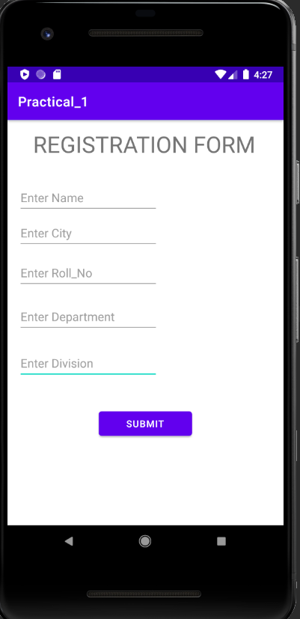 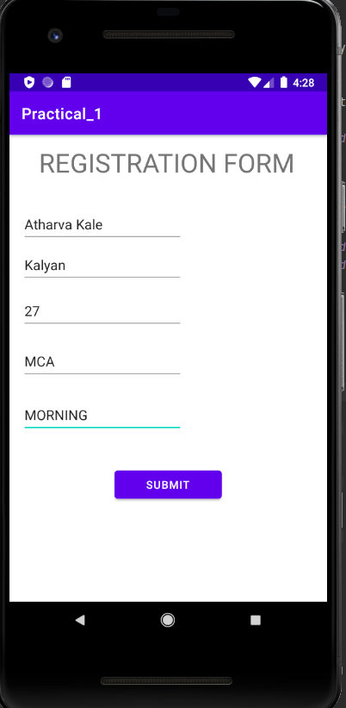

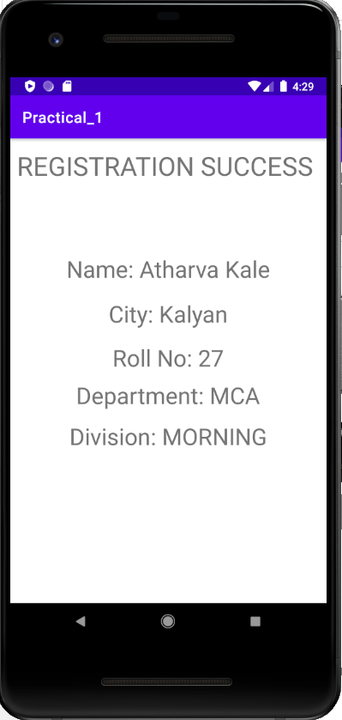

**B) Create an application to design simple calculator to perform addition, subtraction, multiplication and division. Show message for divide by zero error using Toast:**

* **CODE:**
  + **Activity_main.xml:**

<?xml version="1.0" encoding="utf-8"?>  
<AbsoluteLayout xmlns:android="http://schemas.android.com/apk/res/android"  
 xmlns:app="http://schemas.android.com/apk/res-auto"  
 xmlns:tools="http://schemas.android.com/tools"  
 android:layout_width="match_parent"  
 android:layout_height="match_parent"  
 tools:context=".MainActivity">  
  
 <EditText  
 android:id="@+id/editText4"  
 android:layout_width="wrap_content"  
 android:layout_height="wrap_content"  
 android:layout_x="73dp"  
 android:layout_y="119dp"  
 android:ems="10"  
 android:hint="Enter first number"  
 android:inputType="numberDecimal"  
 tools:layout_editor_absoluteX="101dp"  
 tools:layout_editor_absoluteY="87dp" />  
  
 <EditText  
 android:id="@+id/editText5"  
 android:layout_width="wrap_content"  
 android:layout_height="wrap_content"  
 android:layout_x="76dp"  
 android:layout_y="198dp"  
 android:ems="10"  
 android:hint="Enter second number"  
 android:inputType="numberDecimal"  
 tools:layout_editor_absoluteX="101dp"  
 tools:layout_editor_absoluteY="207dp" />  
  
 <Button  
 android:id="@+id/button"  
 android:layout_width="wrap_content"  
 android:layout_height="wrap_content"  
 android:layout_x="64dp"  
 android:layout_y="316dp"  
 android:text="ADD"  
 tools:layout_editor_absoluteX="164dp"  
 tools:layout_editor_absoluteY="335dp" />  
  
 <TextView  
 android:id="@+id/textView"  
 android:layout_width="81dp"  
 android:layout_height="38dp"  
 android:layout_x="135dp"  
 android:layout_y="520dp"  
 android:text="Result"  
 tools:layout_editor_absoluteX="173dp"  
 tools:layout_editor_absoluteY="545dp" />  
  
 <Button  
 android:id="@+id/button2"  
 android:layout_width="wrap_content"  
 android:layout_height="wrap_content"  
 android:layout_x="204dp"  
 android:layout_y="318dp"  
 android:text="Sub" />  
  
 <Button  
 android:id="@+id/button3"  
 android:layout_width="wrap_content"  
 android:layout_height="wrap_content"  
 android:layout_x="65dp"  
 android:layout_y="402dp"  
 android:text="Mult" />  
  
 <Button  
 android:id="@+id/button4"  
 android:layout_width="wrap_content"  
 android:layout_height="wrap_content"  
 android:layout_x="205dp"  
 android:layout_y="398dp"  
 android:text="Div" />  
</AbsoluteLayout>

* + **MainActivity.java:**

package com.example.practical_1b;  
  
import androidx.appcompat.app.AppCompatActivity;  
  
import android.os.Bundle;  
import android.view.View;  
import android.widget.Button;  
import android.widget.EditText;  
import android.widget.TextView;  
import android.widget.Toast;  
  
public class MainActivity extends AppCompatActivity {  
 Button ad,sb,mu,di;  
 EditText n1,n2;  
 TextView tv;  
 @Override  
 protected void onCreate(Bundle savedInstanceState) {  
 super.onCreate(savedInstanceState);  
 setContentView(R.layout.*activity_main*);  
 ad=findViewById(R.id.*button*);  
 sb=findViewById(R.id.*button2*);  
 mu=findViewById(R.id.*button3*);  
 di=findViewById(R.id.*button4*);  
 n1=findViewById(R.id.*editText4*);  
 n2=findViewById(R.id.*editText5*);  
 tv=findViewById(R.id.*textView*);  
 ad.setOnClickListener(  
 new View.OnClickListener() {  
 @Override  
 public void onClick(View v) {  
 int n3=0;  
 String num1=n1.getText().toString();  
 String num2=n2.getText().toString();  
 n3=Integer.*parseInt*(num1)+Integer.*parseInt*(num2);  
 tv.setText(" "+n3);  
 }  
 }  
 );  
 sb.setOnClickListener(  
 new View.OnClickListener() {  
 @Override  
 public void onClick(View v) {  
 int n4=0;  
 String num1=n1.getText().toString();  
 String num2=n2.getText().toString();  
 n4=Integer.*parseInt*(num1)-Integer.*parseInt*(num2);  
 tv.setText(" "+n4);  
 }  
 }  
 );  
 mu.setOnClickListener(  
 new View.OnClickListener() {  
 @Override  
 public void onClick(View v) {  
 int n4=0;  
 String num1=n1.getText().toString();  
 String num2=n2.getText().toString();  
 n4=Integer.*parseInt*(num1)*Integer.*parseInt*(num2);  
 tv.setText(" "+n4);  
  
 }  
 }  
 );  
 di.setOnClickListener(  
 new View.OnClickListener() {  
 @Override  
 public void onClick(View v) {  
 int n4=0;  
 String num1=n1.getText().toString();  
 String num2=n2.getText().toString();  
 if(Integer.*parseInt*(num2)==0)  
 {  
 Toast.*makeText*(MainActivity.this,"Cant Divide By Zero",Toast.*LENGTH_LONG*).show();  
 }  
 else {  
 n4 = Integer.*parseInt*(num1) / Integer.*parseInt*(num2);  
 tv.setText(" " + n4);  
 }  
 }  
 }  
 );  
  
  
  
 }  
}

* **OUTPUT:**
  + **GUI: ADD:**

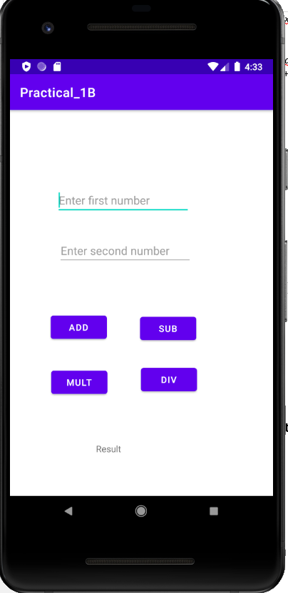 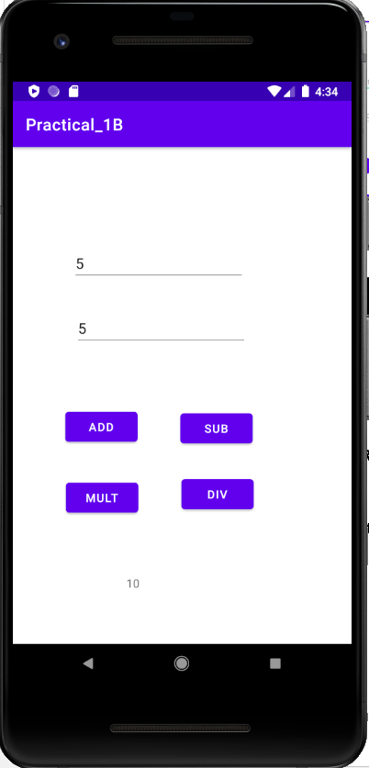

* + **MUL: DIV BY ZERO(TOAST):**

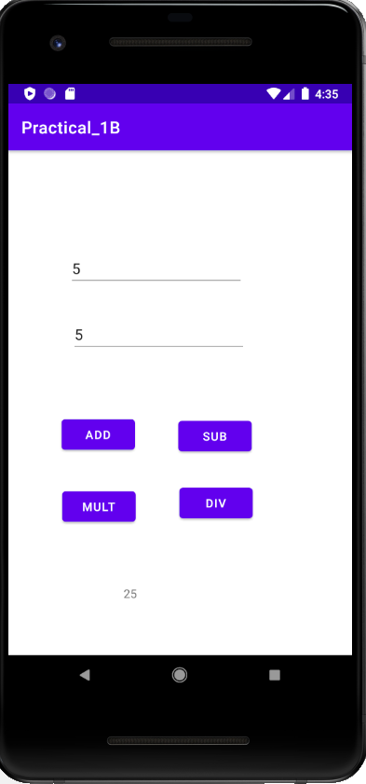 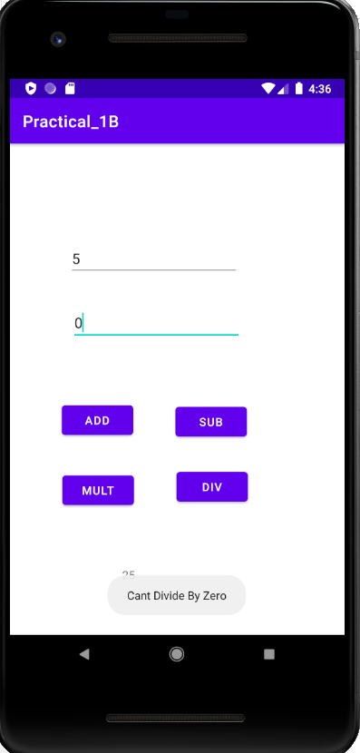

**C) Create an application for Length Conversion:**

* **CODE:**
  + **Activity_main.xml:**

<?xml version="1.0" encoding="utf-8"?>  
<AbsoluteLayout xmlns:android="http://schemas.android.com/apk/res/android"  
 xmlns:app="http://schemas.android.com/apk/res-auto"  
 xmlns:tools="http://schemas.android.com/tools"  
 android:layout_width="match_parent"  
 android:layout_height="match_parent"  
 tools:context=".MainActivity">  
  
 <TextView  
 android:id="@+id/textView5"  
 android:layout_width="144dp"  
 android:layout_height="43dp"  
 android:layout_x="126dp"  
 android:layout_y="92dp"  
 android:text="Select Type"  
 android:textAlignment="center"  
 android:textSize="20sp"  
 app:layout_constraintBottom_toBottomOf="parent"  
 app:layout_constraintEnd_toEndOf="parent"  
 app:layout_constraintHorizontal_bias="0.498"  
 app:layout_constraintStart_toStartOf="parent"  
 app:layout_constraintTop_toTopOf="parent"  
 app:layout_constraintVertical_bias="0.04" />  
  
 <TextView  
 android:id="@+id/textView3"  
 android:layout_width="307dp"  
 android:layout_height="43dp"  
 android:layout_x="45dp"  
 android:layout_y="505dp"  
 android:textAlignment="center"  
 android:textSize="20sp"  
 app:layout_constraintBottom_toBottomOf="parent"  
 app:layout_constraintEnd_toEndOf="parent"  
 app:layout_constraintHorizontal_bias="0.498"  
 app:layout_constraintStart_toStartOf="parent"  
 app:layout_constraintTop_toTopOf="parent"  
 app:layout_constraintVertical_bias="0.04" />  
  
 <TextView  
 android:id="@+id/textView6"  
 android:layout_width="307dp"  
 android:layout_height="43dp"  
 android:layout_x="45dp"  
 android:layout_y="446dp"  
 android:textAlignment="center"  
 android:textSize="20sp"  
 app:layout_constraintBottom_toBottomOf="parent"  
 app:layout_constraintEnd_toEndOf="parent"  
 app:layout_constraintHorizontal_bias="0.498"  
 app:layout_constraintStart_toStartOf="parent"  
 app:layout_constraintTop_toTopOf="parent"  
 app:layout_constraintVertical_bias="0.04" />  
  
 <EditText  
 android:id="@+id/val"  
 android:layout_width="wrap_content"  
 android:layout_height="wrap_content"  
 android:layout_x="92dp"  
 android:layout_y="286dp"  
 android:ems="10"  
 android:inputType="number" />  
  
 <TextView  
 android:id="@+id/textView4"  
 android:layout_width="144dp"  
 android:layout_height="43dp"  
 android:layout_x="129dp"  
 android:layout_y="231dp"  
 android:text="Enter A Value:"  
 android:textAlignment="center"  
 android:textSize="20sp"  
 app:layout_constraintBottom_toBottomOf="parent"  
 app:layout_constraintEnd_toEndOf="parent"  
 app:layout_constraintHorizontal_bias="0.498"  
 app:layout_constraintStart_toStartOf="parent"  
 app:layout_constraintTop_toTopOf="parent"  
 app:layout_constraintVertical_bias="0.04" />  
  
 <Spinner  
 android:id="@+id/sel"  
 android:layout_width="274dp"  
 android:layout_height="wrap_content"  
 android:layout_x="65dp"  
 android:layout_y="157dp"  
 android:visibility="visible" />  
  
 <Button  
 android:id="@+id/button"  
 android:layout_width="wrap_content"  
 android:layout_height="wrap_content"  
 android:layout_x="149dp"  
 android:layout_y="370dp"  
 android:text="CONVERT"  
 app:layout_constraintBottom_toBottomOf="parent"  
 app:layout_constraintEnd_toEndOf="parent"  
 app:layout_constraintHorizontal_bias="0.498"  
 app:layout_constraintStart_toStartOf="parent"  
 app:layout_constraintTop_toTopOf="parent"  
 app:layout_constraintVertical_bias="0.85" />  
  
 <TextView  
 android:id="@+id/textView2"  
 android:layout_width="144dp"  
 android:layout_height="43dp"  
 android:layout_x="137dp"  
 android:layout_y="17dp"  
 android:text="LENGTH"  
 android:textAlignment="center"  
 android:textSize="30sp"  
 app:layout_constraintBottom_toBottomOf="parent"  
 app:layout_constraintEnd_toEndOf="parent"  
 app:layout_constraintHorizontal_bias="0.498"  
 app:layout_constraintStart_toStartOf="parent"  
 app:layout_constraintTop_toTopOf="parent"  
 app:layout_constraintVertical_bias="0.04" />  
  
</AbsoluteLayout>

* + **MainActivity.java:**

package com.example.practical_1c;  
  
import androidx.appcompat.app.AppCompatActivity;  
  
import android.os.Bundle;  
import android.view.View;  
import android.widget.ArrayAdapter;  
import android.widget.Button;  
import android.widget.EditText;  
import android.widget.Spinner;  
import android.widget.TextView;  
  
public class MainActivity extends AppCompatActivity {  
 Spinner s;  
 TextView tv,tv2;  
 String text;  
 Button conv;  
 EditText value;  
 ArrayAdapter<String> adapter;  
 @Override  
 protected void onCreate(Bundle savedInstanceState) {  
 super.onCreate(savedInstanceState);  
 setContentView(R.layout.*activity_main*);  
  
 tv=findViewById(R.id.*textView6*);  
 tv2=findViewById(R.id.*textView3*);  
 conv = findViewById(R.id.*button*);  
 value =findViewById(R.id.*val*);  
 s = findViewById(R.id.*sel*);  
  
 String[] type = {"CM","M","KM"};  
 adapter = new ArrayAdapter(this,android.R.layout.*simple_spinner_dropdown_item*,type);  
 s.setAdapter(adapter);  
 conv.setOnClickListener(  
 new View.OnClickListener() {  
 @Override  
 public void onClick(View v) {  
 TextView textView = (TextView)s.getSelectedView();  
 text = textView.getText().toString();  
 if(text=="CM")  
 {  
 int val = Integer.*parseInt*(value.getText().toString());  
 tv.setText("Value in KiloMeters: "+val*0.00001);  
 tv2.setText("Value in Meters: "+val*0.01);  
 }  
 else if(text=="M")  
 {  
 int val = Integer.*parseInt*(value.getText().toString());  
 tv.setText("Value in KiloMeters: "+val*0.001);  
 tv2.setText("Value in CentiMeters: "+val*100);  
 }  
 else if(text=="KM")  
 {  
 int val = Integer.*parseInt*(value.getText().toString());  
 tv.setText("Value in Meters: "+val*1000);  
 tv2.setText("Value in CentiMeters: "+val*100000);  
 } } }  
 );  
 }}

* **OUTPUT:**
  + **GUI: Centimeter:**

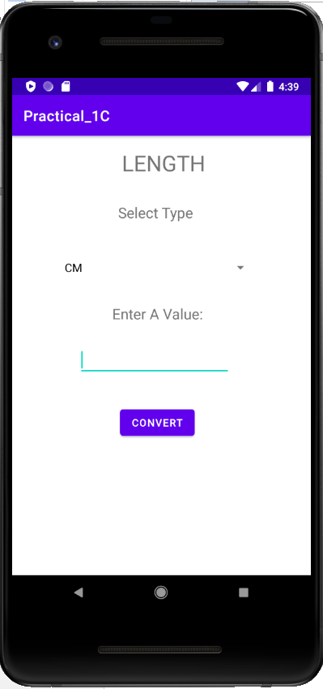 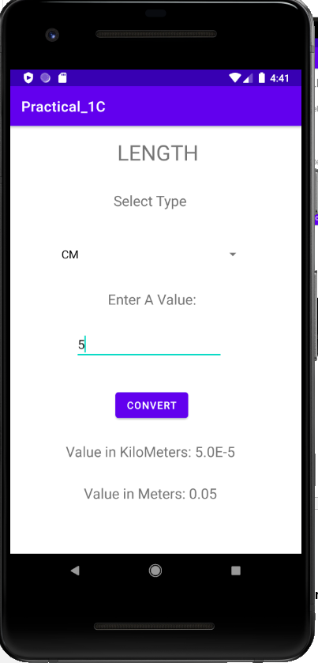

* + **Meter: Kilometer:**

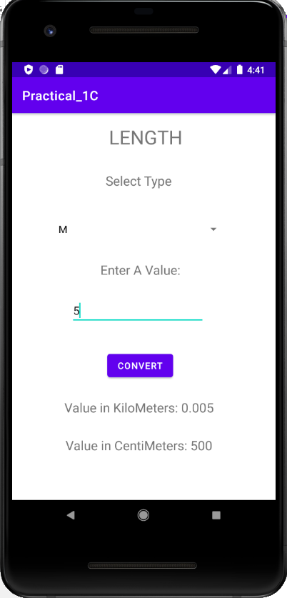 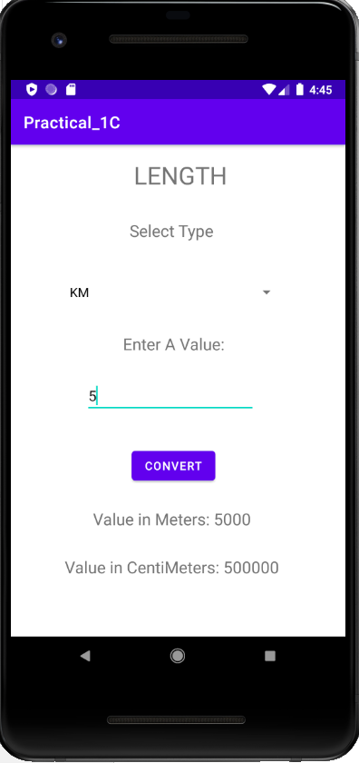

* **CONCLUSION:**

Hence we successfully studied different types of layouts and Toast class.